## Serial

### General

Under “Tools > Configuration > Serial” the following menus are available;

* COM ports
* Serial LAN ports
* CAN ports
* MasterBus Devices
* Overview connected devices.

### COM ports

Under “Tools > Configuration > Serial > COM ports” (see Figure 2‑14) all COM ports as found by NavVision ® become visible. At the first startup they are no COM port yet assigned (i.e. COM port menu does not show any COM port data).

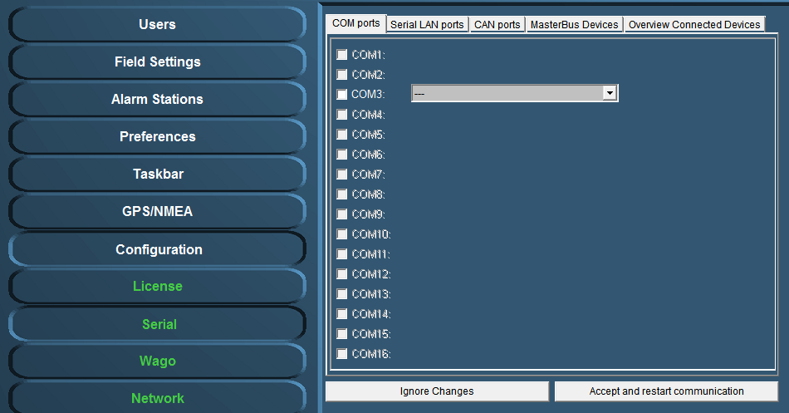

Figure 2‑14: COM ports

#### COM port assignment

*:*

*Use the right device interface (protocol) and verify the baudrate etc.*

Check the respective wiring schematics to determine the COM port arrangement and assignment. Tick off the relevant COM port (1, 2, 3, etc.) and select the required device interface (protocol) by means of the drop-down menu (see Figure 2‑15).

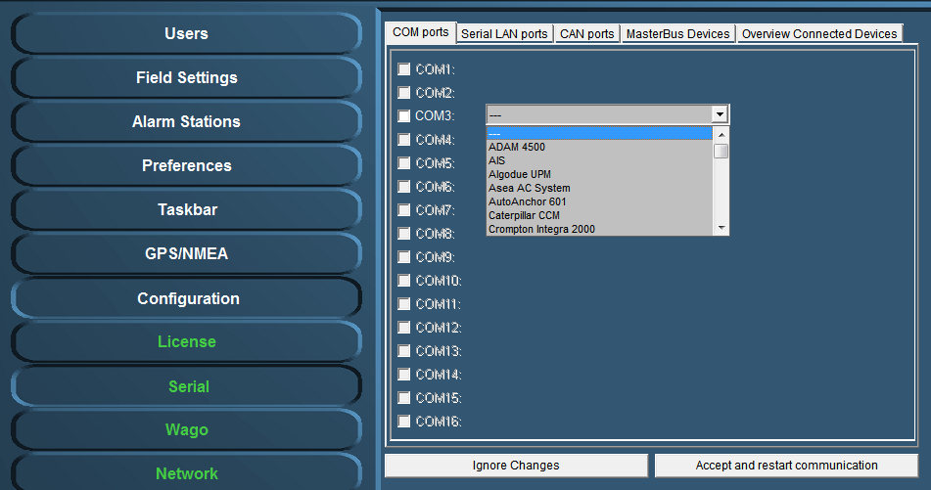

Figure 2‑15: Drop-down menu (device interfaces)

At completion, confirm the settings by clicking “Accept and restart communication” (see Figure 2‑15).

Check the appropriate NavVision ® viewer to verify if the COM-port is correct and if there is any data communication. For example: select the “Video Sounder” viewer (see Figure 2‑16) to verify that the device interface (protocol) on “COM1” is correct. Repeat this procedure for all other listed COM ports.

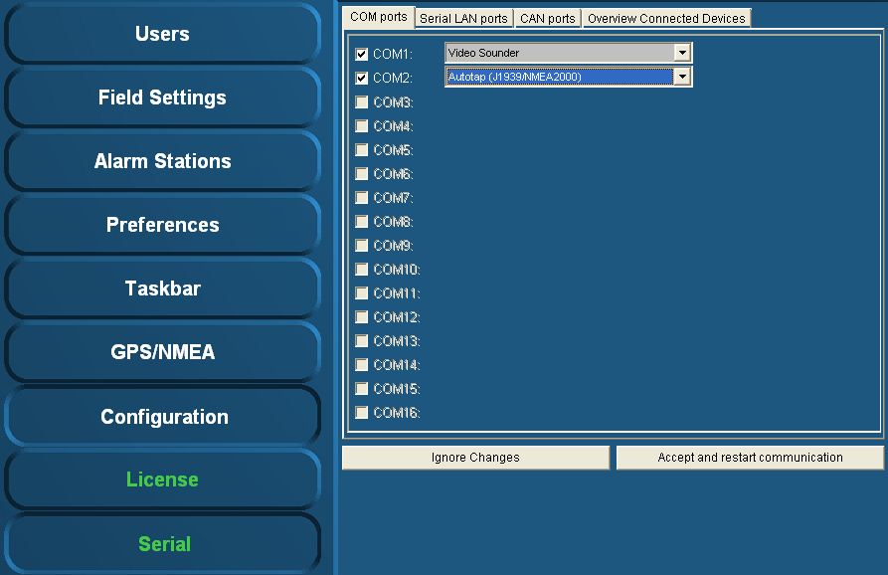

Figure 2‑16: COM port assignment

Additional information on the selected port can be configured by clicking on the sign behind the drop-down menu (see Figure 2‑17). A new box will open.

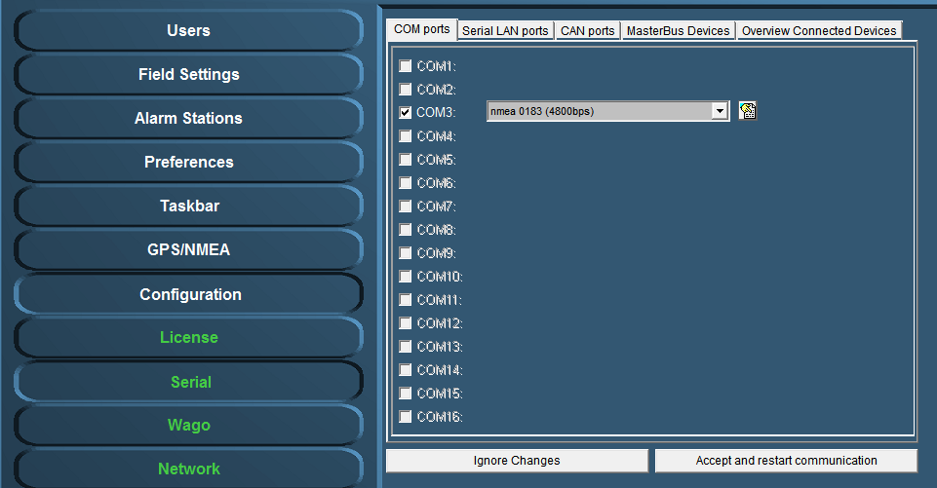

Figure 2‑17: additional configuration

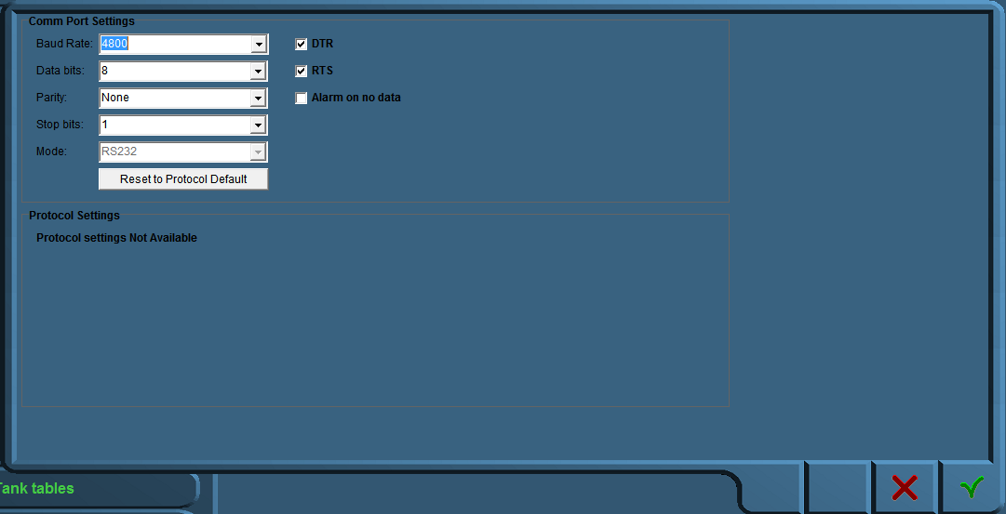

Figure 2‑18: Comm Port Settings

In this additional configuration menu (see Figure 2‑18) you can force all the settings for the regarding Comm port. The following fields apply:

* Baud Rate: Set the appropriate baudrate (see manual attached device)
* Data Bits: The number of data bits in each character can be 5 (for Baudot code), 6 (rarely used), 7 (for true ASCII), 8 (for any kind of data, as this matches the size of a byte), or 9 (rarely used). 8 data bits are almost universally used in newer applications. 5 or 7 bits generally only make sense with older equipment such as teleprinters.
* Parity: The parity bit in each character can be set to none (N), odd (O), even (E), mark (M), or space (S). None means that no parity bit is sent at all. Mark parity means that the parity bit is always set to the mark signal condition (logical 1) and likewise space parity always sends the parity bit in the space signal condition. Aside from uncommon applications that use the 9th (parity) bit for some form of addressing or special signalling, mark or space parity is uncommon, as it adds no error detection information. Odd parity is more common than even, since it ensures that at least one state transition occurs in each character, which makes it more reliable. The most common parity setting, however, is "none", with error detection handled by a communication protocol.
* Stop Bits: Stop bits sent at the end of every character allow the receiving signal hardware to detect the end of a character and to resynchronise with the character stream. Electronic devices usually use one stop bit.
* Mode: In mode you can set the protocol that the serial port is using to communicate. Refer to your device for the proper protocol. You can choose between RS232, RS422 and RS485. In some occasions you can’t choose Mode cause the interface protocol can only work in a predefined Mode (i.e NMEA is always RS232).
* DTR: Data Terminal Ready, indicates presence of DTE to DCE (set high or low)
* RTS: Request to send, DTE requests the DCE prepare to receive data (set high or low)
* Alarm on no data: Gives an alarm when there is no data on the Comm port
* Reset to protocol default: Resets standard configuration for chosen protocol

#### Special note on printers

Under the Com port assignment, if you choose “printer” there will be an additional configuration part. You can set which data you want to be printed by checking the appropriate checkmark (see Figure 2‑19). While NavVision supports two printers, you can add different data to the separate printers.

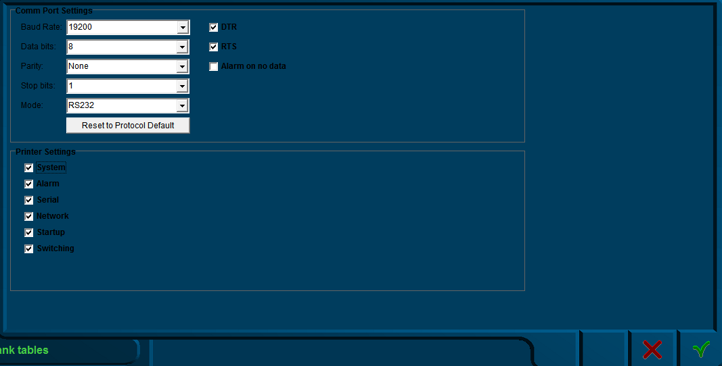

Figure 2‑19: Printer settings

### Serial LAN ports

Under “Serial LAN ports” (see Figure 2‑20) the attached serial LAN device can be addressed and when necessary be calibrated.

The following fields are available;

* Serial LAN server
* Type (serial LAN server)
* IP address
* MAC address
* Data/control port
* LAN1 and LAN2

After installation a calibration procedure must follow, to ensure that the LAN device will function properly.

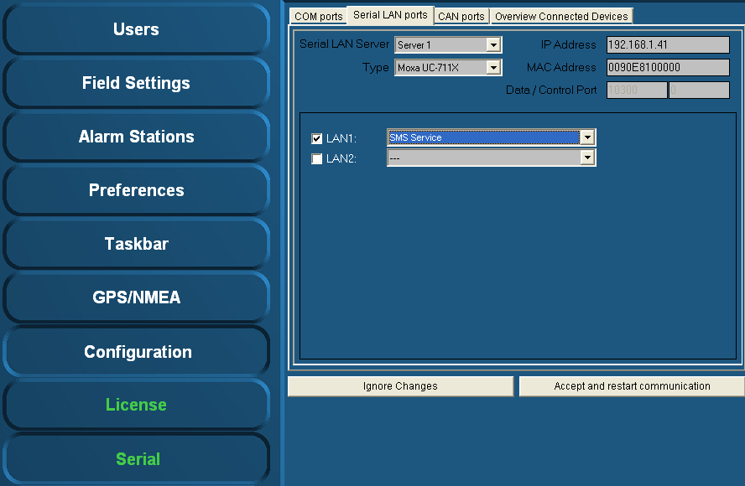

Figure 2‑20: Serial LAN ports

#### Serial LAN server

Under “Serial LAN ports > Serial LAN server” (see Figure 2‑21) the server to be assigned can be selected. In addition under “Type” the LAN server type can be selected.

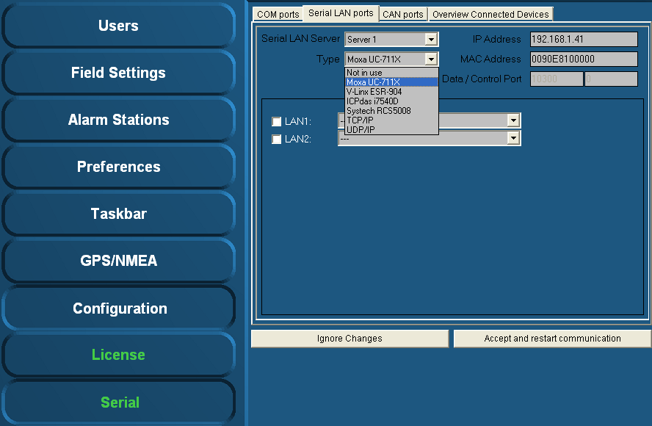

Figure 2‑21: Type (Moxa)

#### Type (Moxa UC-711X)

The Moxa is found under “Type” > “Moxa UC-711X” (see Figure 2‑21).   
Fill in the IP address of the Moxa unit under “IP Address” (use same range as the PC i.e. 172.16.x.x, for Moxa the last digits are in the 40 range).   
The very first connected Moxa unit is set to IP address 172.16.1.41 and the next available to 172.16.1.42 etc.

*:*

*The MAC address can be found on the sticker underneath the unit.*

For the Moxa unit it is necessary to use a MAC address specified under “MAC Address”.

If necessary, verify the LAN1 and/or LAN2 settings and choose the appropriate device interface / protocol (see chapter 2.8.2.1).

To confirm the settings, click “Accept and restart communication” and verify if the serial data is working within NavVision ®.

#### Type (V-Linx ESR-904) *Obsolete*

The V-Linx is found under “Type” > “V-Linx ESR-904” (see Figure 2‑22).   
Fill in the IP address of the V-Linx unit under “IP Address” (use same range as the PC i.e. 172.16.x.x, for V-Linx the last digits are in the 40 range).  
The very first connected V-Linx unit is set to IP address 172.16.1.41 and the next available to 172.16.1.42 etc.

*:*

*Please be aware that multiple units (i.e the Moxa’s) will operate within the same IP address range (172.16.1.4x). Use different IP addresses, otherwise the system may not function properly.*

Verify the LAN1 - LAN4 settings (if available) and select the appropriate device interface / protocol (see 2.8.2.1).

To confirm the settings, click “Accept and restart communication” and verify if the serial data is working within NavVision ®.

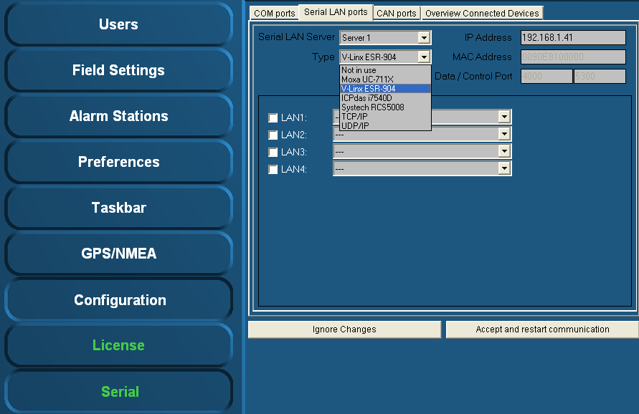

Figure 2‑22: Type (V-Linx ESR-904)

#### Type (ICPdas i7540D)

The ICPdas is found under “Type” “ICPdas i7540D” (see Figure 2‑23).   
Fill in the IP address of the ICPdas server under “IP Address” (same range as the PC i.e. 172.168.x.x, for ICP the last digits are in the 30 range).

The very first connected ICP is set to IP address 172.16.1.31 and the next available to 172.16.1.32 etc.

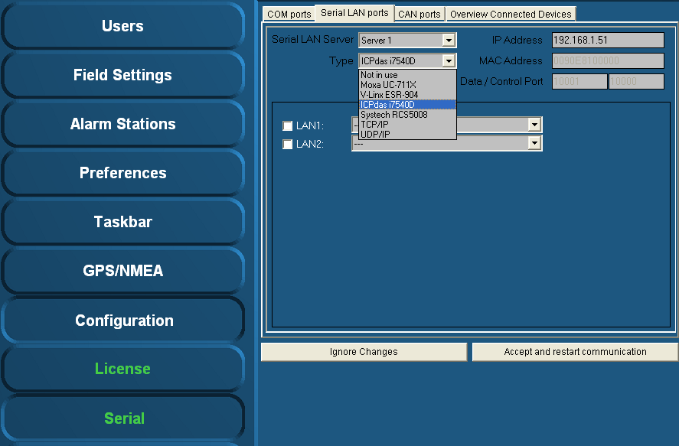

Figure 2‑23: Type (ICPdas i7540D)

Verify the LAN1 and LAN2 settings (if available) and select the appropriate protocol (see 2.8.2.1).

To confirm the settings, click “Accept and restart communication” and verify if the serial data is working within NavVision ®.

### CAN ports

Under “Serial > CAN ports” the following menus are available:

* Interface
* Standard
* IP
* Group.

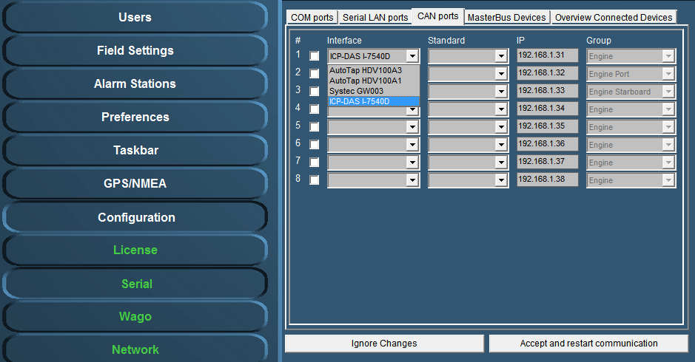

Figure 2‑24: Interface

Under interface you can choose different kinds of Can-interfaces. The most used one is the ICP. If you come across an older version, you can choose it here. (see Figure 2‑24).

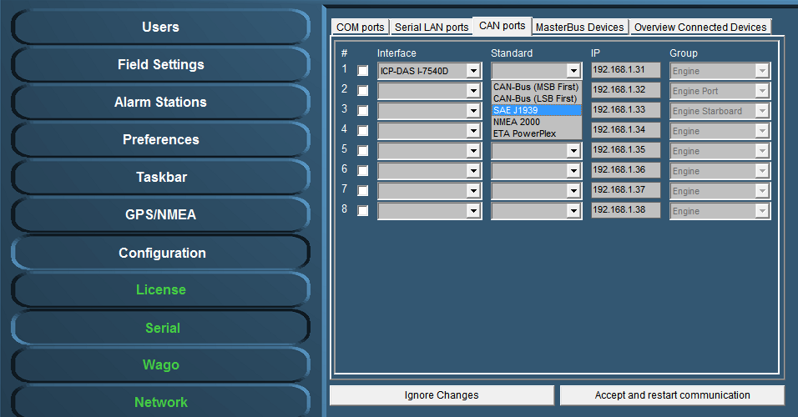

Figure 2‑25: Standard

Under Standard you choose the protocol you want to use with the interface (see Figure 2‑25). Most widely used are the NMEA 2000 and the SAE J1939. Which to use is depending on your attached protocol.

Under IP you can select the right IP address that reflects the connected ICP for example. You can best leave it as it is by default (which will become the 172.16.1.x range). For information on how to set the right IP-address in the ICP, please refer to the ICP installation manual.

The group you choose reflects under which group the information will be stored in NavVision. If you, for example, want the information from the interface to show up under Engine Port, you select that under Group (see Figure 2‑25).

After each change you need to hit “Accept and restart communication” to save it to the system.

### Overview connected devices

*:*

*The installation of serial devices may require some calibration. For example, it may be possible that you need to make some adjustments in the “INI-files”. For more detailed information on this subject please refer to Free Technics .*

Under “Serial > Overview Connected Devices” (see Figure 2‑26) an overview of the connected devices is shown.

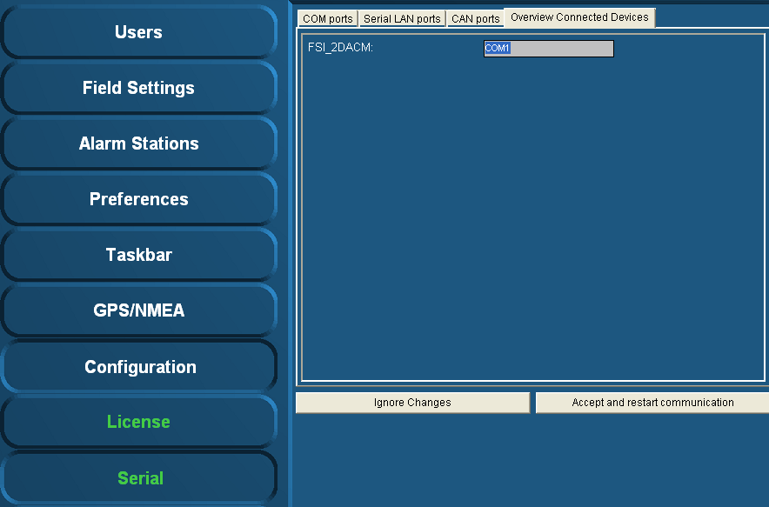

Figure 2‑26: Overview connected devices

### IP-Address standardization

For standardization purposes the same IP-addresses are used throughout each system. In the table below you’ll find the IP-addresses (standard protocol) for most instruments.

|  |  |
| --- | --- |
| **Detail** | **IP-Address** |
| PC I/O | 172.16.x.x (172.16.24.35 for key number 2435) |
| PC I/O next ring | 172.17.x.x (172.17.24.35 for key number 2435) |
| Duty Alarm Panels  (DAP) | Using range x.x.1.8y  Depending on the network connected, this will result in:  DAP 1: 172.16.1.81  DAP 2: 172.16.1.82  DAP 3: 172.16.1.83 |
| Serial LAN servers | Using range 172.16.1.4x (attached to I/O subnet 172.16) INT 1: 172.16.1.41 INT 2: 172.16.1.42 INT 3: 172.16.1.43 |
| Wago | Using range 172.16.1.9x (attached to I/O subnet 172.16) Wago substation 1: 172.16.1.91 Wago substation 2: 172.16.1.92 Wago substation 3: 172.16.1.93 |
| CAN-Interface | Using range 172.16.1.3x (attached to I/O subnet 172.16) CAN interface 1: 172.16.1.31 CAN interface 2: 172.16.1.32 CAN interface 3: 172.16.1.33 |
| Axis | Using range 172.16.1.24x (attached to I/O subnet 172.16) Axis cam server 1: 172.16.1.241 Axis cam server 2: 172.16.1.242 Axis cam server 3: 172.16.1.243 |